

DATA STRUCTURES AND ALGORITHM
23CSE203
LAB MANUAL

SUBMITTED BY
NAME | BHUMA SANVIKA
ROLL NO | AV.SC.U4CSE25020
YEAR/SEM/SECTION | 2nd YEAR /SEM-3/CSE A
CREDITS | 05

SUBMITTED TO | DR. RAJ KUMAR BATCHU
DESIGNATION | ASST.PROFFESSOR (Sl. Grade)
DEPARTMENT | SCHOOL OF COMPUTING

INDEX

SNO (lab) | PROGRAM | PAGE NO
Lab 1 | 1: A rocket launch system displays a countdown before launch. Instead of using a loop, implement the countdown using recursion. Write a recursive Python program to display a countdown from n to 1, followed by “launch”.  2: Banks calculate the growth of an investment using compound interest. The formula requires calculating powers. Which can be implemented recursively. Write a recursive program to calculate p^n(power), where p=principal growth factor, n= number of years  3: An HR department stores employee ID’s in a list. Develop a recursive program to search for a given employee ID. Write a recursive function to search for an employee ID in a list.  4: In a logistics company, the number of possible ways to arrange n different parcels is calculated using the factorial formula(n!). Develop a recursive program to calculate the factorial of a given number  5: Write a recursive Python program to print the first n terms of the Fibonacci series. | 3-9
Lab2 | A) write a python program to perform linear search on the given input  B) Write a python program to perform binary search on the given input. Verify by taking sorted array and unsorted array as a list. | 10-15
Lab3 | A) write a python program to sort the elements using a bubble sort technique. Take an input elements from the user.  B) Insertion sort  C)selection sort  D)Merge sort  E) Quick sort | 15-24

Lab4 | A)Write a python program to implement a single linked list which would perform the below operations, by taking an input from the user.  a. create a linked list  b. Insert at beginning. c. Insert at end. d. Insert at a specific index.  e. Delete by value.  f. Delete 1st node.  g. Delete last node.  h. Count no. of nodes i. Display.  j. Exit.  B)Doubly linked list  C) circular linked list | 24-60
Lab5 | A) stack using array  B) stack using linked list | 60-70

LAB -1
1)AIM: A rocket launch system displays a countdown before launch. Instead of using a loop implement the countdown using recursion .write a recursion python program to display a countdown from n to 1 followed by “launch”.
PROGRAM:
def launch(n):
for i in range(n,-1,-1):

if i==0:
print("launch")

else:
print(i)

n=int(input("enter no. of seconds to launch:"))
launch(n)

OUTPUT:
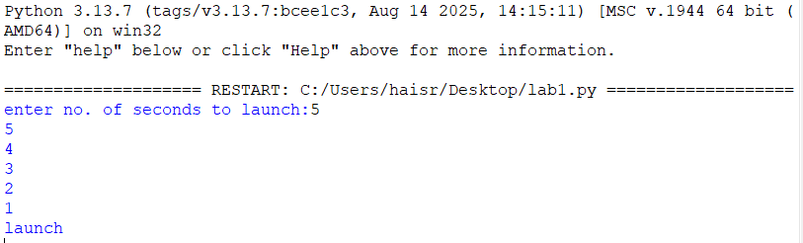

EXPLANATION:
This program displays a countdown from n to 1 and finally prints 'launch'. Although the aim mentions recursion, the given code uses a loop.

ERROR TABLE:
ERROR | CAUSE | SOLUTION
Indentation Error | Incorrect indentation | Align blocks properly
Name Error | Variable not defined | Define before use
Value Error | Non-integer input | Enter valid integer

2)AIM: banks calculate the growth of an investment using compoundinterest the formula requires calculating powers. Which can be implemented recursively. Write a recursive program to calculate p^n(power),where p=principal growth factor, n= number of years.
PROGRAM:
def intrest(p,n):
if n==0:
return 1
else:
return p*intrest(p,n-1)
n=int(input("enter no.of years:"))
p=int(input("enter a number:"))
res=intrest(p,n)
print(res)
OUTPUT:
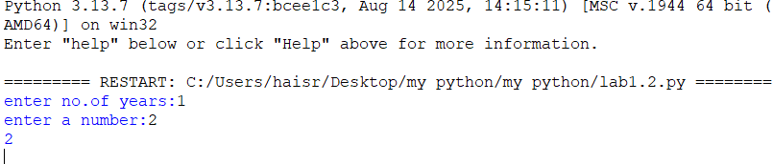EXPLANATION:This program recursively calculates p^n by multiplying p until n becomes 0.
ERROR TABLE:
ERROR | CAUSE | SOLUTION
Recursion error | Very large value of n | Reduce input
Name Error | Wrong function/variable name | Check spelling
Value Error | Non-integer input | Enter valid integer
3)AIM: An HR department stores employee ID’s in a list. Develop a recursive program to search for a given employee ID .write a recursive function to search for an employee ID in a list.
PROGRAM:
def search(m):

key=m
for i in range(n-1):
if arr[i]==key:
return i

n=int(input("enter no.of employees to add:"))
arr=[]
for i in range(n):
a=int(input("enter a value:"))
arr.append(a)
print(arr)
m=int(input("enter a element to search:"))
result=search(m)
if result==-1:
print(“element is not found”)
else:
print("employee id is stored at the index:",result)
OUTPUT:
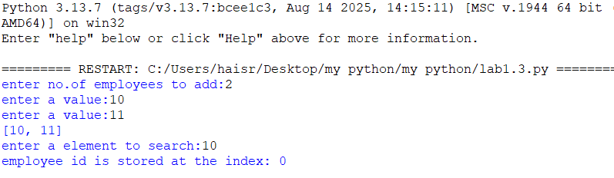

EXPLANATION:
This program searches for an employee ID in a list and returns its index if found.
ERROR TABLE:
ERROR | CAUSE | SOLUTION
Syntax error | Wrong quotes/brackets | Correct syntax
Logic error | Returns None instead of -1 | Return -1 when not found

4)AIM: In a logistics company the number of possible ways to arrange n different parcels is calculated using the factorial formula(n!). develop a recursive program to calculate the factorial of a given number.
PROGRAM:
def fact(n):
fact=1
for i in range(1,n+1):
fact=fact*i

return fact
n=int(input("enter a number to find its factorial:"))
result=fact(n)
print(result)
OUTPUT:
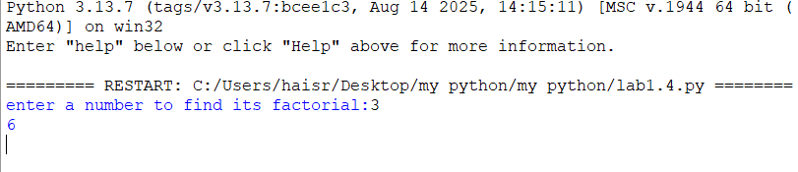

EXPLANATION:This program calculates the factorial of a number using iteration (not recursion).
ERROR TABLE:
ERROR | CAUSE | SOLUTION
Overflow/large input | Large input value | Give smaller input
Value error | Invalid input | Even integer

5)AIM: write a recursive python program to print the first n terms of the Fibonacci series.
PROGRAM:
def fib(n):
if n==0:
return 0
elif n==1:
return 1
else:
return fib(n-1)+fib(n-2)

n=int(input("enter no of terms:"))
if n<=-1:
print("invalid input")
else:
for i in range(n):
print(fib(i),end=" ")
OUTPUT:
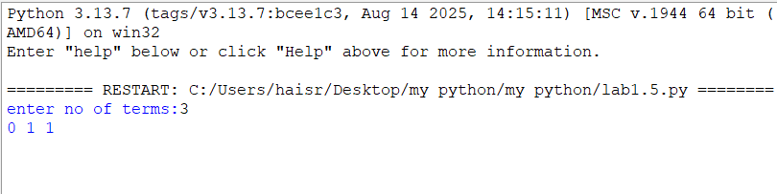
EXPLANATION:
The program uses recursion to generate Fibonacci numbers. fib (0)=0 and fib (1) =1 are the base cases. For every other term, fib(n)=fib(n-1) + fib(n-2). The loop prints the first n terms.

ERROR TABLE:
ERROR | CAUSE | SOLUTION
Recursion error | Large value of n | Use iteration
Invalid input | Negative value of n | Validate input
Slow execution | Repeated recursive calls | Use dynamic programming

PROGRAM | TIME COMPLEXITY | SPACE COMPLEXITY | REASON
1.countdown to launch |  |  | The program uses a loop that prints from n to 0 once.
  O(n)
  O(1)
2.power calculation |  |  | One recursive call is made for each value of n. The recursion stack stores n calls.
  O(n)
  O(n)
3.employee ID search |  |  | The program performs a linear search through the list.
  O(n)
  O(1)
4.Factorial |  |  | The program calculates factorial using a loop from 1 to n.
  O(n)
  O(1)
5.Fibonacci series
  O(2ⁿ)
  O(n)
  Each function call creates two more recursive calls, leading to exponential time. The recursion stack reaches depth n.

LAB-2

1.AIM: Write a program to perform linear search on a given input.
PROGRAM:
def linear_search(arr,key):
for i in range(len(arr)):
if arr[i]==key:
return i
return -1

n = int(input("Enter no. of elements:"))
arr=[]
print("Enter the elements:")
for i in range(n):
arr.append(int(input()))
key=int(input("Enter element to search:"))
result=linear_search(arr,key)
if result!=-1:
print("Element found at index",result)
else:
print("Element not found.")
OUTPUT:
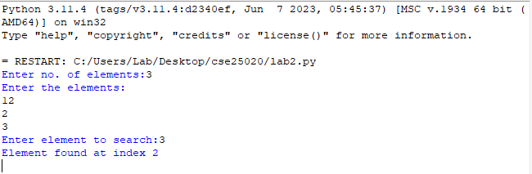

EXPLANATION:
- The linear_search() function checks each element of the list one by one and compares it with the given key.
- If the key is found, its index is returned; otherwise, the function returns -1.
- The program takes the array and search element as input and displays whether the element is found.
ERROR TABLE:
S.no. | Errors | Rectification
1. | ValueError occurs if a non-integer value is entered when int(input()) is used. | Enter only integer values for the number of elements and array elements.
2. | TypeError may occur if len(arr) is used on a variable that is not a list. | Make sure arr is initialized as a list using arr = [] and elements are appended to it.

2.AIM: Write a Python program to perform binary search on the given input. Verify by taking sorted array and unsorted array as input.
PROGRAM:
def binary_search(arr,key):
low=0
high=len(arr)-1
while low<=high:
mid=(low+high)//2
if arr[mid]==key:
return mid
elif arr[mid]<key:
low=mid+1
else:
high=mid-1
return -1

n = int(input("Enter no. of elements:"))
arr=[]
print("Enter the elements:")
for i in range(n):
arr.append(int(input()))

key=int(input("Enter element to search:"))
result=binary_search(arr,key)
if result!=-1:
print("Element found at index",result)
else:
print("Element not found.")
OUTPUT:
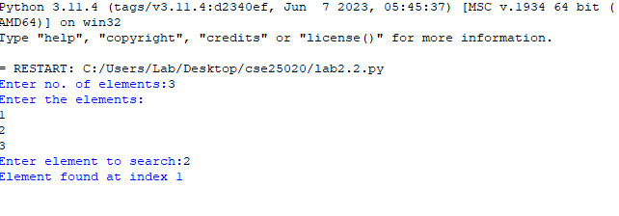

3.PROGRAM:
def binary_search(arr,key):
low=0
high=len(arr)-1
while low<=high:
mid=(low+high)//2
if arr[mid]==key:
return mid
elif arr[mid]<key:
low=mid+1
else:
high=mid-1
return -1

n = int(input("Enter no. of elements:"))
arr=[]
print("Enter the elements:")
for i in range(n):
arr.append(int(input()))
if arr==sorted(arr):
print("\n The input list is already sorted.")
else:
print("\n The input list is not sorted.")
print("Sorting the list...")
arr.sort()
print("Sorted list.",arr)
key=int(input("Enter element to search:"))
result=binary_search(arr,key)
if result!=-1:
print("Element found at index",result)
else:
print("Element not found.")
OUTPUT:
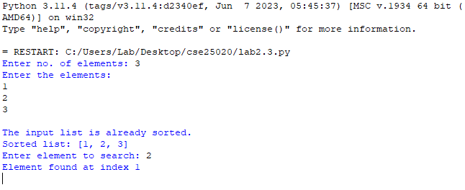EXPLANATION:
- The binary_search() function repeatedly divides the sorted list into two halves and compares the middle element with the search key.
- If the middle element is smaller than the key, the search continues in the right half; otherwise, it searches the left half.
- The second program verifies whether the input is sorted and sorts it using arr.sort() if necessary before performing binary search.

ERROR TABLE:
S.no. | Errors | Rectification
1. | Binary search may give an incorrect result if the input array is unsorted. | Check whether the array is sorted and use arr.sort() before calling binary_search().
2. | IndexError can occur if mid is calculated or the low/high boundaries are modified incorrectly. | Initialize low = 0, high = len(arr) - 1 and update them as low = mid + 1 or high = mid - 1.

LAB-3
AIM: 3a. Write a python program to sort the elements using a bubble sort technique. Take the input elements from the user.
Program:
n = int(input("Enter the number of elements: "))
arr = []
print("Enter the elements:")
for i in range(n):
arr.append(int(input()))
for i in range(n - 1):
for j in range(n - i - 1):
if arr[j] < arr[j + 1]:
arr[j], arr[j + 1] = arr[j + 1], arr[j]
print("Elements after Bubble Sort:")
print(arr)
Output:
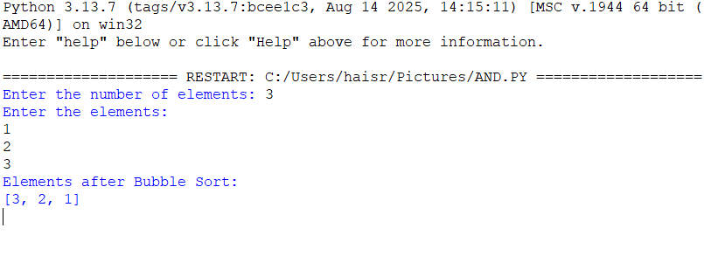Explanation:
• n = int(input(...)) – Gets the number of elements.
• arr = [] – Creates an empty list to store elements.
• for i in range(n) – Takes n elements as input.
• arr.append(...) – Adds each element to arr.
• for i in range(n - 1) – Performs Bubble Sort passes.
• for j in range(n - i - 1) – Compares adjacent elements.
• if arr[j] < arr[j + 1] – Checks if the current element is smaller.
• arr[j], arr[j + 1] = ... – Swaps the elements to sort in descending order.
• print(arr) – Displays the sorted list.
Error Table:
S.NO | Error Obtained | Rectification
1. | Sorting Order Error – Using > instead of < in the if condition changes the order to ascending. | Use if arr[j] < arr[j + 1]: for descending order.

AIM: 3b.Write a python program to sort the elements using a insertion sort technique. Take the input elements from the user.
Program:
def insertion_sort(arr):
n = len(arr)
for i in range (1,n):
key = arr[i]
j = i - 1
while j >= 0 and arr[j] > key:
arr[j+1] = arr[j]
j = j - 1
arr[j+1] = key
return arr
n = int(input("Enter the number of elements: "))
arr = []
print("Enter the elements:")
for i in range(n):
element = int(input())
arr.append(element)
result = insertion_sort(arr)
print("Elements after Insertion Sort:")
print(result)
Output:
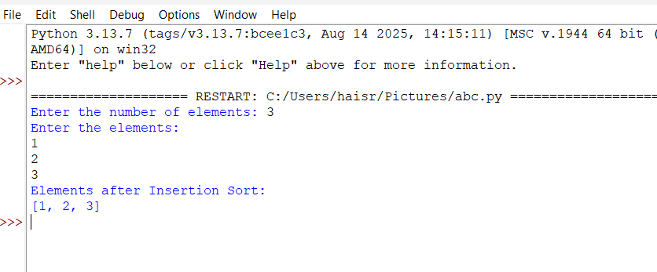

Explanation:
• n = len(arr) – Gets the list size.
• for i in range(1, n) – Selects elements from the second position.
• key = arr[i] – Stores the current element.
• j = i - 1 – Sets the previous index.
• while j >= 0 and arr[j] > key – Compares previous elements with key.
• arr[j + 1] = arr[j] – Shifts larger elements right.
• arr[j + 1] = key – Inserts key in the correct position.
• return arr – Returns the sorted list.
• result = insertion_sort(arr) – Calls the function.
• print(result) – Displays the sorted list.
ERROR TABLE:
S.NO | Error Obtained | Rectification
1. | Insertion Error – Placing key at the wrong index. | Use arr[j + 1] = key after shifting elements.
2. | Function Call Error – Not calling insertion_sort(arr) correctly. | Pass the input list arr to the function.

AIM: 3c.Write a python program to sort the elements using a selection sort technique. Take the input elements from the user.
Program:
def selection_sort(arr):
n=len(arr)
for i in range(n-1):
min_index=i
for j in range (i+1,n):
if arr[j]<arr[min_index]:
min_index=j
arr[i],arr[min_index]=arr[min_index],arr[i]
return arr
n=int(input("Enter the number of elements: "))
arr=[]
print("Enter the elements:")
for i in range(n):
element=int(input())
arr.append(element)
result=selection_sort(arr)
print("Elements after Selection Sort:")
print(result)
Output:
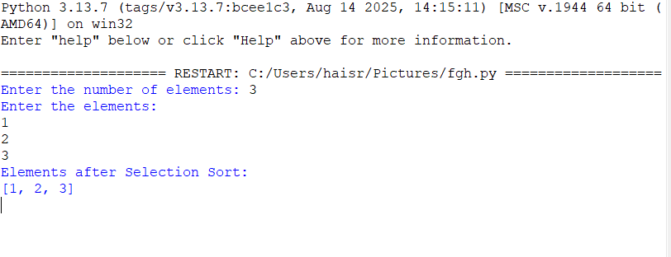

Explanation:
• def selection_sort(arr) – Defines the Selection Sort function.
• n = len(arr) – Gets the number of elements in arr.
• for i in range(n-1) – Performs sorting passes.
• min_index = i – Assumes the first element is the smallest.
• for j in range(i+1,n) – Checks the remaining elements.
• if arr[j] < arr[min_index] – Finds the smallest element.
• arr[i], arr[min_index] = ... – Swaps the smallest element into position.
• return arr – Returns the sorted list.
• result = selection_sort(arr) – Calls the function.
• print(result) – Displays the sorted list in ascending order.

Error Table:

S.NO | Error Obtained | Rectification
1. | Swap Error – Incorrectly swapping the elements. | Use arr[i], arr[min_index] = arr[min_index], arr[i].
2. | Minimum Index Error – Incorrectly assigning min_index. | Use min_index = i.

AIM: 3d.Write a python program to sort the elements using a merge sort technique. Take the input elements from the user.
Program:
def merge_sort(arr):
if len(arr) <= 1:
return arr
mid=len(arr)//2
left=merge_sort(arr[:mid])
right=merge_sort(arr[mid:])
i = j = k = 0
while i < len(left) and j < len(right):
if left[i] <= right[j]:
arr[k] = left[i]
i += 1
else:
arr[k] = right[j]
j += 1
k += 1
while i < len(left):
arr[k] = left[i]
i += 1
k += 1
while j < len(right):
arr[k] = right[j]
j += 1
k += 1
return arr
n = int(input("Enter the number of elements: "))
arr = []
print("Enter the elements:")
for i in range(n):
element = int(input())
arr.append(element)
result = merge_sort(arr)
print("Elements after Merge Sort:")
print(result)
Output:
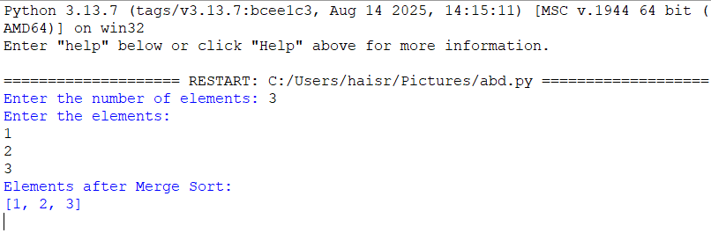

Explanation:
• def merge_sort(arr) – Defines the Merge Sort function.
• if len(arr) <= 1 – Stops when the list has one or no elements.
• mid = len(arr)//2 – Finds the middle of the list.
• left and right – Divide the list into two halves recursively.
• i = j = k = 0 – Initializes the indexes.
• while loops – Compare and merge the elements.
• if left[i] <= right[j] – Selects the smaller element.
• arr[k] – Places the selected element in the list.

Error Table:
S.NO | Error Obtained | Rectification
1. | Index Error – Incorrectly updating i, j, or k. | Increment the appropriate index after each insertion.
2. | Recursion Error – Incorrectly dividing the list. | Use arr[:mid] and arr[mid:].

AIM: 3e.Write a python program to sort the elements using a quick sort technique. Take the input elements from the user.
Program:
def quicksort(a,low,high):
if low < high:
i = low
j = high
pivot = low
while i < j:
while i < len(a) and a[i]<=a[pivot]:
i +=1
while a[j] > a[pivot]:
j = j -1
if i < j:
a[i],a[j] = a[j],a[i]
a[j],a[pivot] = a[pivot],a[j]
quicksort(a,low,j-1)
quicksort(a,j+1,high)
a = list(map(int,input("Enter numbers to sort:").split(" ")))
n = len(a)
quicksort(a,0,n-1)
print("Sorted array:")
print(a)
Output:
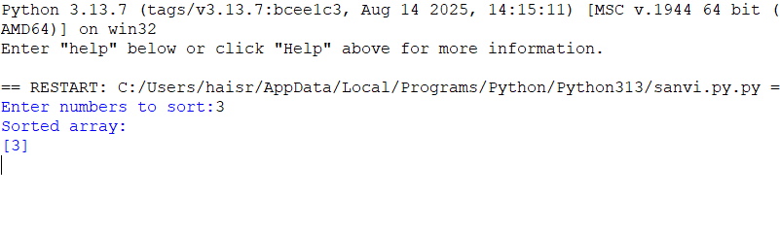

Explanation:
• def quicksort(a, low, high) – Defines the Quick Sort function.
• if low < high – Checks the sorting range.
• i and j – Set left and right positions.
• pivot = low – Selects the first element as pivot.
• while i < j – Performs partitioning.
• Inner while loops – Find elements for swapping.
• a[i], a[j] = ... – Swaps elements.
• a[j], a[pivot] = ... – Places the pivot correctly.
• quicksort() calls – Sort the two partitions.
• input().split() – Takes space-separated numbers.
• print(a) – Displays the sorted array.

Error Table:
S.NO | Error Obtained | Rectification
1. | Pivot Error – Incorrectly selecting the pivot index. | Use pivot = low.
2. | Swap Error – Incorrect swapping of a[i] and a[j]. | Use a[i], a[j] = a[j], a[i].

LAB-4
4. AIM: Write a python program to implement a single linked list which would perform the below operations, by taking an input from the user.
1. Create a linked list. 2. Insert at beginning. 3. Insert at end.
4. Insert at a specific index. 5. Delete by value. 6. Delete 1st node. 7. Delete last node. 8. Count no. of nodes 9. Display.
10. Exit.
Programme:
class Node:
def __init__(self, data):
self.data = data
self.next = None

class LinkedList:
def __init__(self):
self.head = None

def insert_begin(self, data):
new = Node(data)
new.next = self.head
self.head = new

def insert_end(self, data):
new = Node(data)

if self.head is None:
self.head = new
else:
temp = self.head
while temp.next:
temp = temp.next
temp.next = new

def deleteAtBeg(self):
if self.head is None:
print("No Data to delete")
else:
temp = self.head
self.head = temp.next
print("Deleted Value =", temp.data)

def deleteAtEnd(self):
if self.head is None:
print("No Data to delete")

elif self.head.next is None:
print("Deleted Value =", self.head.data)
self.head = None

else:
temp = self.head

while temp.next.next:
temp = temp.next

print("Deleted Value =", temp.next.data)
temp.next = None

def delete(self, value):
if self.head is None:
print("No Data to delete")
return

temp = self.head

if temp.data == value:
self.head = temp.next
print("Value deleted")
return

while temp.next and temp.next.data != value:
temp = temp.next

if temp.next is None:
print("Value not present")
else:
temp.next = temp.next.next
print("Value deleted")

def count(self):
if self.head is None:
print("No Linked List")
else:
c = 0
temp = self.head

while temp:
c += 1
temp = temp.next

print(f"Number of nodes = {c}")

def display(self):
if self.head is None:
print("No Linked List")
else:
temp = self.head

while temp:
print(temp.data, end=" -> ")
temp = temp.next

print("None")

ll = LinkedList()

while True:
print("\n--- Singly Linked List ---")
print("1. Insert at Beginning")
print("2. Insert at End")
print("3. Delete at Beginning")
print("4. Delete at End")
print("5. Delete a Value")
print("6. Count Nodes")
print("7. Display")
print("8. Exit")

choice = int(input("Enter your choice: "))

if choice == 1:
data = int(input("Enter data: "))
ll.insert_begin(data)

elif choice == 2:
data = int(input("Enter data: "))
ll.insert_end(data)

elif choice == 3:
ll.deleteAtBeg()

elif choice == 4:
ll.deleteAtEnd()

elif choice == 5:
value = int(input("Enter value to delete: "))
ll.delete(value)

elif choice == 6:
ll.count()

elif choice == 7:
ll.display()

elif choice == 8:
print("Program ended")
break

else:
print("Invalid choice")

output:
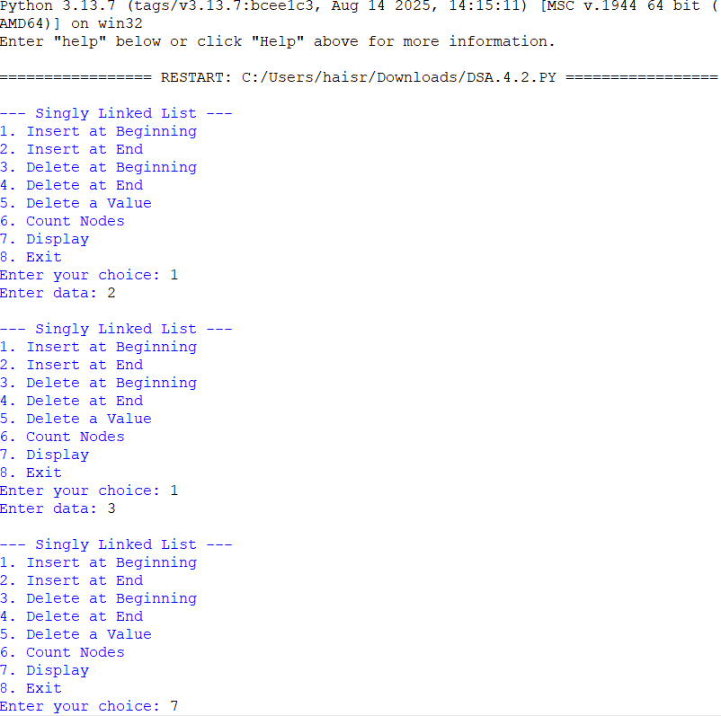
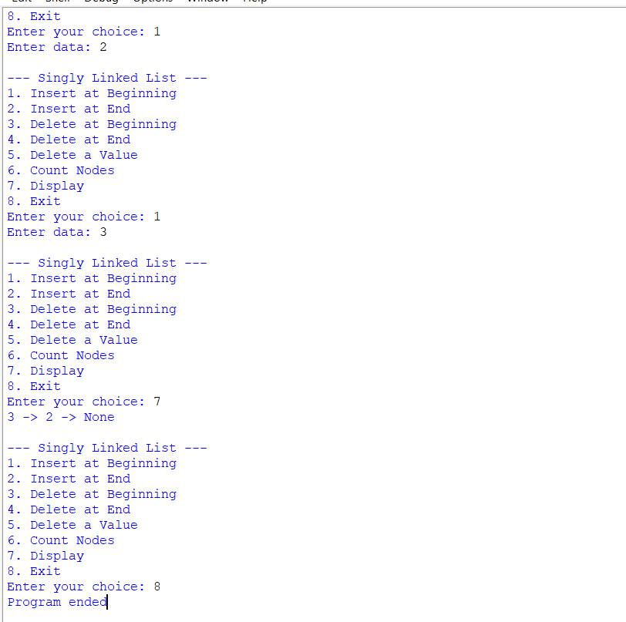

Explanation:
1)Class Definitions:
- Node class o Represents a single node in the linked list. o Each node has:
▪ data → stores the value.
▪ next → pointer to the next node (initially None).
- SLL class o Manages the linked list operations. Has a head pointer (initially None) that points to the first node.
2)Insert at Beginning:
• Creates a new node.
• Points its next to current head.
• Updates head to new node.
3)Insert at End
• Creates a new node.
• If list is empty → new node becomes head.
• Otherwise → traverses to last node and attaches new node.
4) Insert at Index
• Asks for index and data.
• If index = 0 → behaves like "insert at beginning".
• Otherwise → traverses to (index-1) node and inserts new node in between.
5) Delete from Beginning
• Moves head to head.next.
• Effectively removes the first node.
6) Delete from End
• If list empty → prints "List is empty".
• If only one node → sets head = None.
• Otherwise → traverses to second-last node and sets its
next= None.
7) Delete from Index
• Asks for index.
• If index = 0 → removes head.
• Otherwise → traverses to (index-1) node and skips the next node.
8) Count Nodes
• Traverses through list.
• Counts nodes until None.
9) Display
• Traverses from head to end.
• Prints each node’s data in data -> data -> None format.
Error table:
sno | error | rectification
1. | new.next = None | new.next = self.head
2. | Logical error in insertion if index is negative. | Validate index: if index < 0: print ("Invalid index").
3. | temp.next = temp.next.next | temp.next = None (when deleting the last node)

Aim: Write a python program to implement a doubly linked list which would perform the below operations, by taking an input from the user.
1. Create a linked list. 2. Insert at beginning. 3. Insert at end.
4. Insert at a specific index. 5. Delete by value. 6. Delete 1st node. 7. Delete last node. 8. Count no. of nodes 9. Display.
10. Exit.
Programme:
class Node:
def __init__(self, data):
self.data = data
self.prev = None
self.next = None

class DoublyLinkedList:
def __init__(self):
self.head = None

def insert_begin(self, data):
new_node = Node(data)

if self.head is None:
self.head = new_node
else:
new_node.next = self.head
self.head.prev = new_node
self.head = new_node

def insert_end(self, data):
new_node = Node(data)

if self.head is None:
self.head = new_node
else:
temp = self.head

while temp.next is not None:
temp = temp.next

temp.next = new_node
new_node.prev = temp

def insert_at_position(self, data, position):
new_node = Node(data)

if position == 1:
self.insert_begin(data)
return

temp = self.head
count = 1

while temp is not None and count < position - 1:
temp = temp.next
count += 1

if temp is None:
print("Invalid position")
return

new_node.next = temp.next
new_node.prev = temp

if temp.next is not None:
temp.next.prev = new_node

temp.next = new_node

def delete_begin(self):
if self.head is None:
print("List is empty")
return

self.head = self.head.next

if self.head is not None:
self.head.prev = None

def delete_end(self):
if self.head is None:
print("List is empty")
return

temp = self.head

if temp.next is None:
self.head = None
return

while temp.next is not None:
temp = temp.next

temp.prev.next = None

def delete_at_position(self, position):
if self.head is None:
print("List is empty")
return

if position == 1:
self.delete_begin()
return

temp = self.head
count = 1

while temp is not None and count < position:
temp = temp.next
count += 1

if temp is None:
print("Invalid position")
return

if temp.next is not None:
temp.next.prev = temp.prev

if temp.prev is not None:
temp.prev.next = temp.next

def count(self):
temp = self.head
count = 0

while temp is not None:
count += 1
temp = temp.next

print("Number of nodes:", count)

def display(self):
if self.head is None:
print("List is empty")
return

temp = self.head

print("Doubly Linked List:", end=" ")

while temp is not None:
print(temp.data, end=" <-> ")
temp = temp.next

print("END")

dll = DoublyLinkedList()
while True:
print("\n--- DOUBLY LINKED LIST ---")
print("1. Insert Begin")
print("2. Insert End")
print("3. Insert at Specific Position")
print("4. Delete Begin")
print("5. Delete End")
print("6. Delete at Specific Position")
print("7. Count")
print("8. Display")
print("9. End")

choice = int(input("Enter your choice: "))

if choice == 1:
data = int(input("Enter data: "))
dll.insert_begin(data)

elif choice == 2:
data = int(input("Enter data: "))
dll.insert_end(data)

elif choice == 3:
data = int(input("Enter data: "))
position = int(input("Enter position: "))
dll.insert_at_position(data, position)

elif choice == 4:
dll.delete_begin()

elif choice == 5:
dll.delete_end()

elif choice == 6:
position = int(input("Enter position: "))
dll.delete_at_position(position)

elif choice == 7:
dll.count()

elif choice == 8:
dll.display()

elif choice == 9:
print("Program ended")
break

else:
print("Invalid choice")

output:
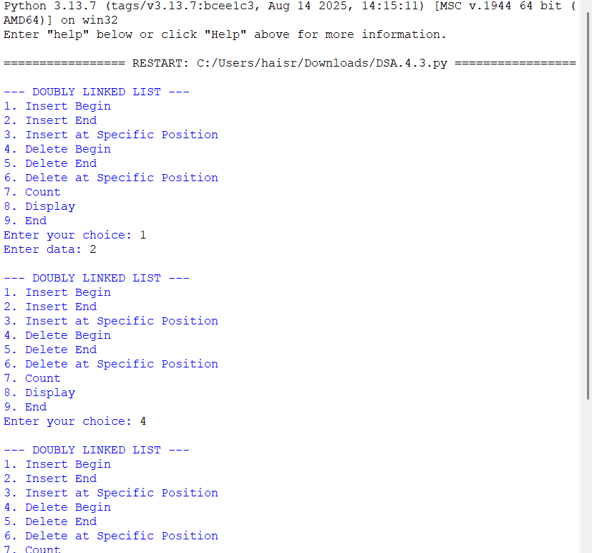
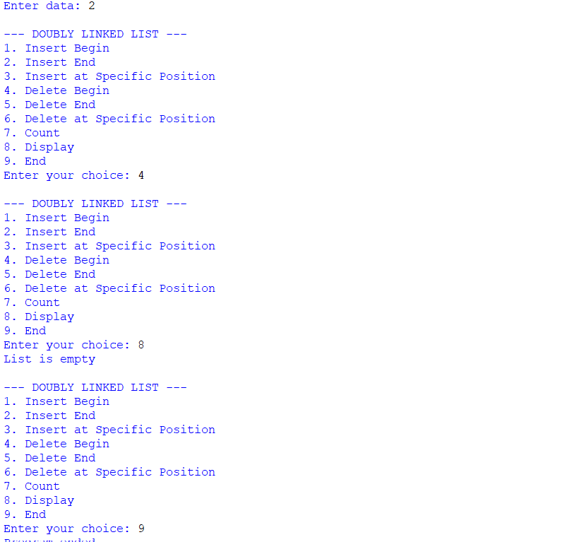

Explanation:
- Node has 3 parts:
  - data → stores value
  - prev → points to previous node
  - next → points to next node
- Doubly Linked List:
  - Each node can move in both directions.
  - First node's prev is None.
  - Last node's next is None.
  - Example: None ← 10 ↔ 20 ↔ 30 → None
Operations
- Insert at Beginning
  - Create a new node.
  - New node points to the current head.
  - Current head's prev points to new node.
  - New node becomes the head.
- Insert at End
  - Traverse to the last node.
  - Last node's next points to new node.
  - New node's prev points to the last node.
- Delete from Beginning
  - Move head to the next node.
  - Set new head's prev to None.
  - If only one node exists, list becomes empty.
- Delete from End
  - Traverse to the last node.
  - Set the previous node's next to None.
  - If only one node exists, list becomes empty.
- Display Forward
  - Start from head.
  - Move using next.
  - Continue until None.
- Display Backward
  - First move to the last node.
  - Move backward using prev.
  - Continue until None.
- Main Program
  - Create a doubly linked list.
  - Display the menu.
  - Take user's choice.
  - Perform the selected operation.
  - Choice 7 exits the program.
Error table:
sno | error | rectification
1. | new_node.prev = None | new_node.prev = temp
2. | new_node.next = None | new_node.next = self.head
3. | self.head.prev = None | self.head.prev = new_node

Aim: Write a python program to implement a circular linked list which would perform the below operations, by taking an input from the user.
1. Create a linked list. 2. Insert at beginning. 3. Insert at end.
4. Insert at a specific index. 5. Delete by value. 6. Delete 1st node. 7. Delete last node. 8. Count no. of nodes 9. Display.
10. Exit.
Programme:

class Node:
def __init__(self, data):
self.data = data
self.next = None

class CircularLinkedList:
def __init__(self):
self.head = None

# Insert at beginning
def insert_begin(self, data):
new_node = Node(data)

if self.head is None:
self.head = new_node
new_node.next = self.head
else:
temp = self.head

while temp.next != self.head:
temp = temp.next

new_node.next = self.head
temp.next = new_node
self.head = new_node

# Insert at end
def insert_end(self, data):
new_node = Node(data)

if self.head is None:
self.head = new_node
new_node.next = self.head
else:
temp = self.head

while temp.next != self.head:
temp = temp.next

temp.next = new_node
new_node.next = self.head

# Insert at specific position
def insert_at_position(self, data, position):
if position == 1:
self.insert_begin(data)
return

new_node = Node(data)
temp = self.head
count = 1

while temp.next != self.head and count < position - 1:
temp = temp.next
count += 1

if count != position - 1:
print("Invalid position")
return

new_node.next = temp.next
temp.next = new_node

# Delete beginning
def delete_begin(self):
if self.head is None:
print("List is empty")
return

if self.head.next == self.head:
self.head = None
return

temp = self.head

while temp.next != self.head:
temp = temp.next

self.head = self.head.next
temp.next = self.head

# Delete end
def delete_end(self):
if self.head is None:
print("List is empty")
return

if self.head.next == self.head:
self.head = None
return

temp = self.head

while temp.next.next != self.head:
temp = temp.next

temp.next = self.head

# Delete at specific position
def delete_at_position(self, position):
if self.head is None:
print("List is empty")
return

if position == 1:
self.delete_begin()
return

temp = self.head
count = 1

while temp.next != self.head and count < position - 1:
temp = temp.next
count += 1

if temp.next == self.head:
print("Invalid position")
return

temp.next = temp.next.next

# Count
def count(self):
if self.head is None:
print("Number of nodes: 0")
return

temp = self.head
count = 0

while True:
count += 1
temp = temp.next

if temp == self.head:
break

print("Number of nodes:", count)

# Display
def display(self):
if self.head is None:
print("List is empty")
return

temp = self.head

print("Circular Linked List:", end=" ")

while True:
print(temp.data, end=" -> ")
temp = temp.next

if temp == self.head:
break

print("HEAD")

# Main program
cll = CircularLinkedList()
while True:
print("\n--- CIRCULAR LINKED LIST ---")
print("1. Insert Begin")
print("2. Insert End")
print("3. Insert at Specific Position")
print("4. Delete Begin")
print("5. Delete End")
print("6. Delete at Specific Position")
print("7. Count")
print("8. Display")
print("9. End")
choice = int(input("Enter your choice: "))

if choice == 1:
data = int(input("Enter data: "))
cll.insert_begin(data)

elif choice == 2:
data = int(input("Enter data: "))
cll.insert_end(data)

elif choice == 3:
data = int(input("Enter data: "))
position = int(input("Enter position: "))
cll.insert_at_position(data, position)

elif choice == 4:
cll.delete_begin()

elif choice == 5:
cll.delete_end()

elif choice == 6:
position = int(input("Enter position: "))
cll.delete_at_position(position)

elif choice == 7:
cll.count()

elif choice == 8:
cll.display()

elif choice == 9:
print("Program ended")
break
else:
print("Invalid choice")
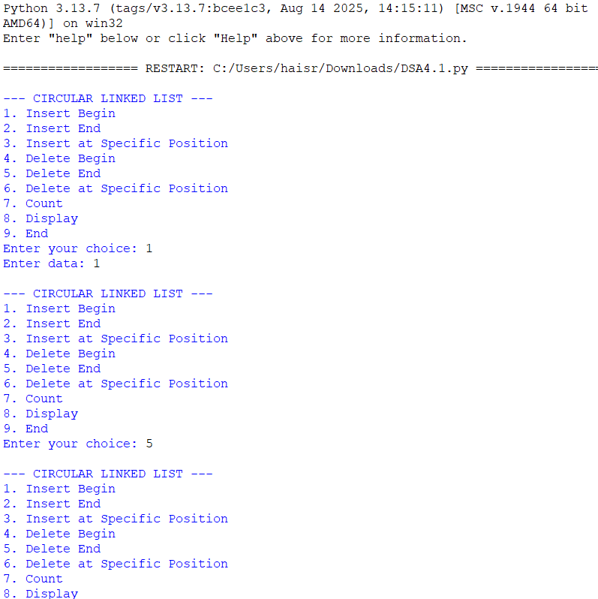
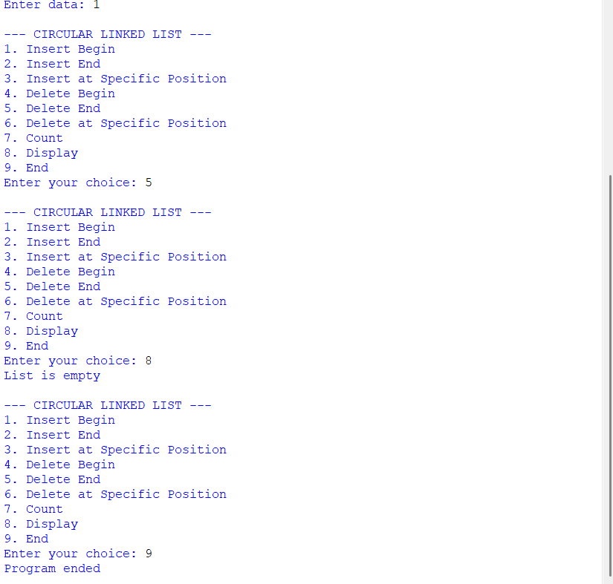
Explanation:
- Node contains two parts:
  - data → stores the value.
  - next → stores the reference of the next node.
- Circular Linked List:
  - Last node points back to the first node (head).
  - There is no None at the end.
  - Example: 10 → 20 → 30 → 10
Operations
- Create
  - Creates n nodes.
  - First node becomes head.
  - Last node points to head.
- Insert at Beginning
  - Create a new node.
  - New node points to current head.
  - Last node points to new node.
  - New node becomes the new head.
- Insert at End
  - Traverse until the last node.
  - Last node points to the new node.
  - New node points to head.
- Insert at Specific Index
  - Move to the node before the required index.
  - Connect the new node between two nodes.
  - Newnode.next = temp.next
  - temp.next = new.node
- Delete by Value
  - Search for the required value.
  - If found, remove that node.
  - Previous node is connected to the next node.
  - Special cases: only node or deleting the head.
- Delete First Node
  - Move head to the second node.
  - Last node is connected to the new head.
- Delete Last Node
  - Find the second-last node.
  - Make its next point to head.
- Count Nodes
  - Start from head.
  - Traverse until reaching head again.
  - Count each node.
- Display
  - Start from head.
  - Print each node.
  - Stop when head is reached again.

Error table:

sno | error | rectification
1. | new_node.next = None | self.head = new_node
2. | self.head = None | self.head = new_node
3. | Indentation Error In the Count node part | It was rectified later, By maintaining proper indentation.

LAB-5
AIM: Write a programe of stack using array
Programme:
stack = []
def push():
element = int(input("Enter element to push: "))
stack.append(element)
print(element, "pushed into stack")
def pop():
if len(stack) == 0:
print("Stack is empty")
else:
print(stack.pop(), "popped from stack")
def peek():
if len(stack) == 0:
print("Stack is empty")
else:
print("Top element is:", stack[-1])
def display():
if len(stack) == 0:
print("Stack is empty")
else:
print("Stack elements are:")
for i in reversed(stack):
print(i)
while True:
print("\n1. Push")
print("2. Pop")
print("3. Peek")
print("4. Display")
print("5. Exit")

choice = int(input("Enter your choice: "))

if choice == 1:
push()
elif choice == 2:
pop()
elif choice == 3:
peek()
elif choice == 4:
display()
elif choice == 5:
print("Program ended")
break
else:
print("Invalid choice")
output:
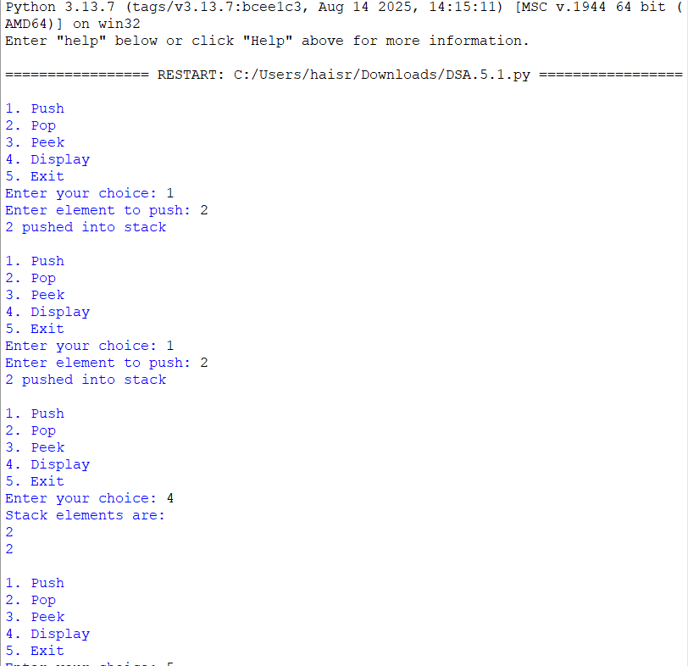
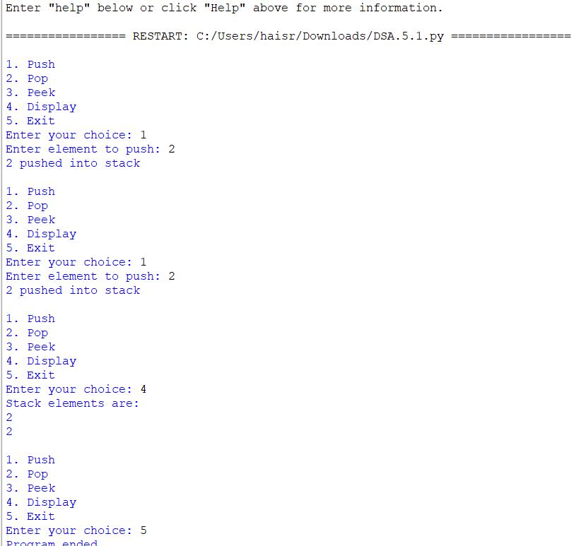

Explanation:
- Stack is a linear data structure.it follows the LIFO (last in first out).
- Elements are stored in the array
- Push is used to insert an element. The element is added at the top. If the stack is full, Stack Overflow occurs.
- Pop is used to remove an element.
- The top element is removed.
- top is decreased. If the stack is empty, Stack Underflow occurs.
- Peek is used to view the top element.
- It does not remove the element.
- Display is used to show all elements.
- Elements are displayed from top to bottom.
- Error table:
Error | Rectified
stack.append() | stack.append(element)
stack.pop(0) | stack.pop()

AIM: Stack using Linked list.
Programme:
class Node:
def __init__(self, data):
self.data = data
self.next = None
top = None
def push():
global top

element = int(input("Enter element to push: "))

new_node = Node(element)
new_node.next = top
top = new_node

print(element, "pushed into stack")
def pop():
global top

if top is None:
print("Stack is empty")
else:
print(top.data, "popped from stack")
top = top.next
def peek():
if top is None:
print("Stack is empty")
else:
print("Top element is:", top.data)
def display():
if top is None:
print("Stack is empty")
else:
temp = top
print("Stack elements are:")

while temp is not None:
print(temp.data)
temp = temp.next
while True:
print("\n1. Push")
print("2. Pop")
print("3. Peek")
print("4. Display")
print("5. Exit")

choice = int(input("Enter your choice: "))

if choice == 1:
push()
elif choice == 2:
pop()
elif choice == 3:
peek()
elif choice == 4:
display()
elif choice == 5:
print("Program ended")
break
else:
print("Invalid choice")
output:
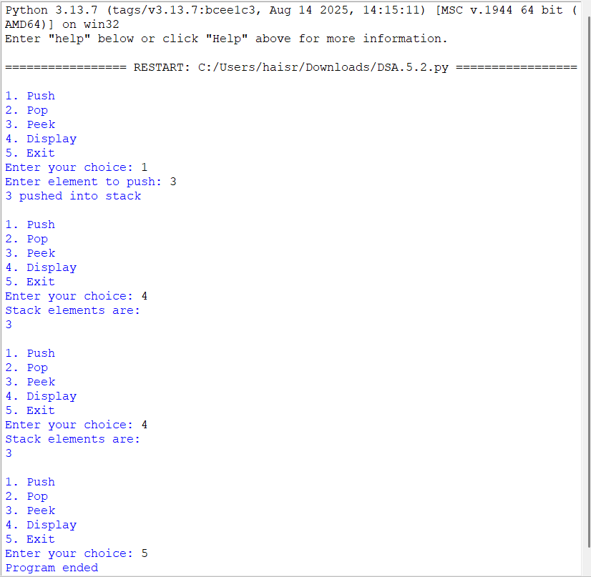
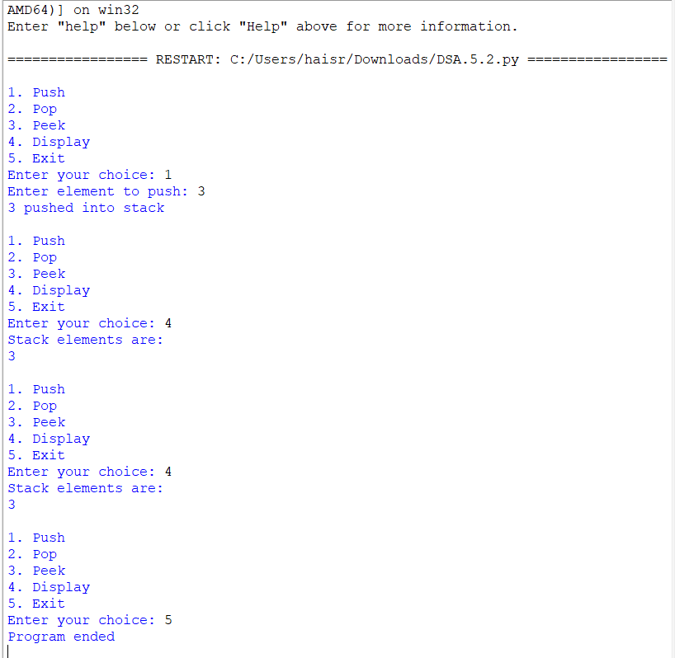

Explanation:
- A stack using linked list is a linear data structure that follows the LIFO (Last In, First Out) principle.
- In a linked-list stack, each element is stored in a node, and each node contains data and a link to the next node.
- A variable called top is used to point to the first node, which represents the top of the stack.
- Push operation is used to insert a new element. A new node is created and added at the top of the stack.
Pop operation is used to remove an element. The node pointed to by top is removed and top moves to the next node.
- Peek operation is used to view the top element without removing it from the stack.
- Display operation is used to traverse the linked list from top to None and display all the elements.
- A linked-list stack has dynamic size, so memory is allocated as needed. Stack Underflow occurs when we try to remove an element from an empty stack.
Error Table:
Error | Rectified
new.next = None | new_node.next = top
top = top | top = new_node

Lab-6
6a. AIM: Write a python program to implement queue and its operations such as enqueue, dequeue, peek, display with a menu driven approach implement using array, linked list.
PROGRAM: Using array
class QueueEx:
def __init__(self, size=5):
self.size = size
self.queue = [None] * size
self.front = -1
self.rear = -1

def enqueue(self, x):
if self.rear == self.size - 1:
print("Queue Overflow")
else:
if self.front == -1:
self.front = 0

self.rear += 1
self.queue[self.rear] = x
print(f"{x} inserted into the queue")

def dequeue(self):
if self.front == -1 or self.front > self.rear:
print("Queue Underflow")
else:
x = self.queue[self.front]
self.queue[self.front] = None
self.front += 1
print(f"{x} deleted from the queue")

if self.front > self.rear:
self.front = -1
self.rear = -1

def peek(self):
if self.front == -1:
print("Queue is empty")
else:
print("Front element:", self.queue[self.front])

def display(self):
if self.front == -1:
print("Queue is empty")
else:
print("The elements of the queue are:")
for i in range(self.front, self.rear + 1):
print(self.queue[i])

size = int(input("Enter the size of Queue: "))
q = QueueEx(size)

while True:
print("\n----- Queue Menu -----")
print("1. Enqueue")
print("2. Dequeue")
print("3. Peek")
print("4. Display")
print("5. Exit")

choice = int(input("Enter your choice: "))

if choice == 1:
item = int(input("Enter the element to enqueue: "))
q.enqueue(item)

elif choice == 2:
q.dequeue()

elif choice == 3:
q.peek()

elif choice == 4:
q.display()

elif choice == 5:
print("Exiting Program")
break

else:
print("Invalid choice")

output:-
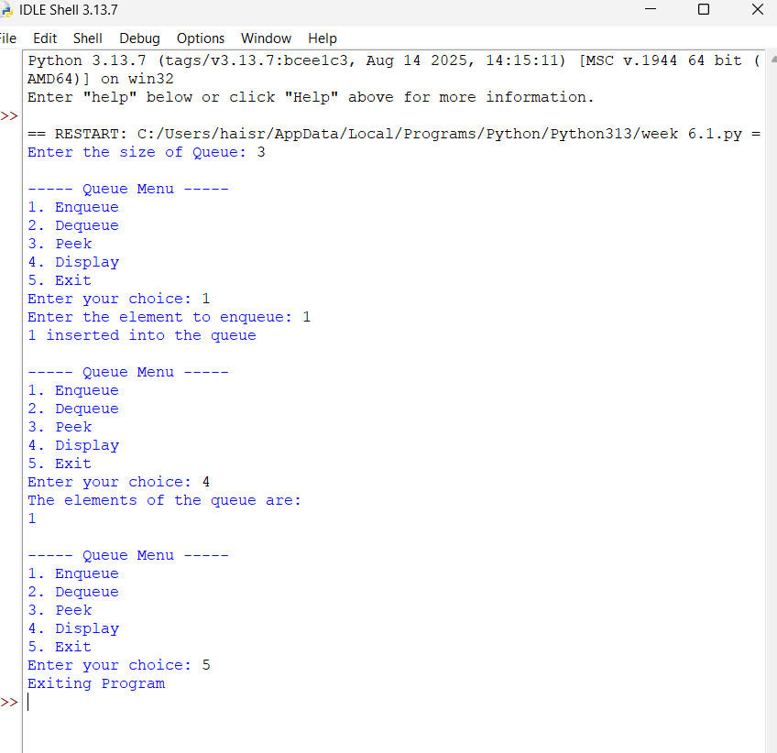
PROGRAM: Using linked list:
class QueueEx:
def __init__(self, size=5):
self.size = size
self.queue = [None] * size
self.front = -1
self.rear = -1

def enqueue(self, x):
if self.rear == self.size - 1:
print("Queue Overflow")
else:
if self.front == -1:
self.front = 0

self.rear += 1
self.queue[self.rear] = x
print(f"{x} inserted into the queue")

def dequeue(self):
if self.front == -1:
print("Queue Underflow")
else:
x = self.queue[self.front]
self.queue[self.front] = None

print(f"{x} deleted from the queue")
self.front += 1

if self.front > self.rear:
self.front = -1
self.rear = -1

def peek(self):
if self.front == -1:
print("Queue is empty")
else:
print("Front element:", self.queue[self.front])

def display(self):
if self.front == -1:
print("Queue is empty")
else:
print("The elements of the queue are:")
for i in range(self.front, self.rear + 1):
print(self.queue[i])

size = int(input("Enter the size of Queue: "))
q = QueueEx(size)

while True:
print("\n----- Queue Menu -----")
print("1. Enqueue")
print("2. Dequeue")
print("3. Peek")
print("4. Display")
print("5. Exit")

choice = int(input("Enter your choice: "))

if choice == 1:
item = int(input("Enter the element to enqueue: "))
q.enqueue(item)

elif choice == 2:
q.dequeue()

elif choice == 3:
q.peek()

elif choice == 4:
q.display()

elif choice == 5:
print("Exiting Program")
break

else:
print("Invalid Choice!")

output:-
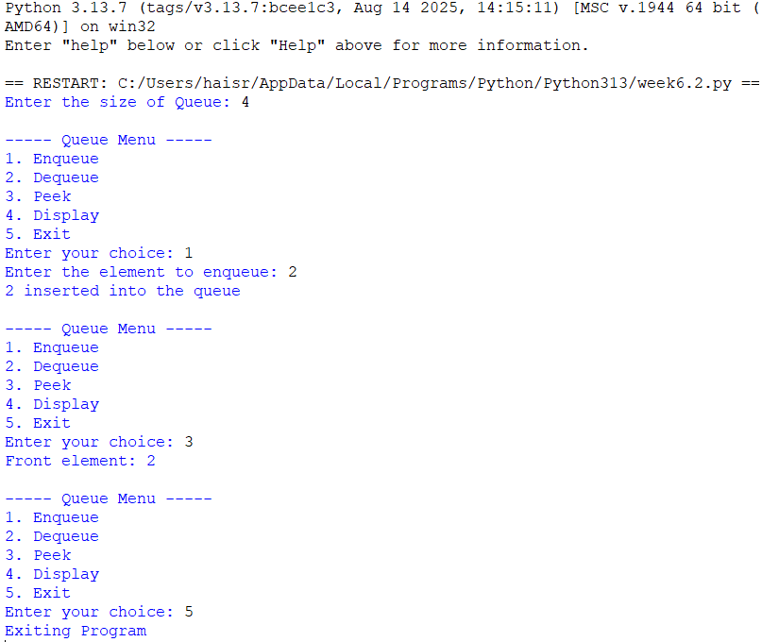
EXPLANATION:
· class QueueEx: Creates a class named QueueEx for implementing the queue.
· __init__(self, size=5): Constructor that initializes the queue with a default size of 5.
· self.size = size : Stores the user-given queue size.
· self.queue = [None] * size : Creates a list of the given size and initializes all positions with None.
· self.front = -1 : Initializes front to indicate that the queue is empty.
· self.rear = -1 : Initializes rear to indicate that no element is present.
enqueue()
· if self.rear == self.size - 1: Checks whether rear has reached the last position.
· self.front = 0 : Sets the front position when inserting the first element.
· self.rear += 1 : Increases rear to the next position.
· self.queue[self.rear] = x : Stores x at the rear position.
· print() : Displays the insertion message.
dequeue()
· if self.front == -1 or self.front > self.rear: Checks whether the queue is empty.
· x = self.queue[self.front] : Stores the front element in x.
· self.queue[self.front] = None : Removes the front element from the list.
· self.front += 1 : Moves front to the next position.
· if self.front > self.rear: : Checks whether all elements have been deleted.
· self.front = -1 and self.rear = -1 : Resets the queue to the empty state.
peek()
· if self.front == -1: Checks whether the queue is empty.
· self.queue[self.front] : Accesses and displays the front element without deleting it.
display()
· if self.front == -1: Checks whether the queue is empty.
· range(self.front, self.rear + 1) : Traverses the queue from front to rear.
· print(self.queue[i]) : Displays each queue element.
ERROR TABLE:
S.NO Error Obtained Rectification
1.
Queue Overflow occurs when the queue is full.
Check if self.rear == self.size - 1 before inserting an element.
2. Queue Underflow occurs when the queue is empty. Check if self.front == -1 or self.front > self.rear before deleting an element.

6b. AIM: Write a python program to implement queue and its operations such as enqueue, dequeue, peek, display with a menu driven approach implement using circular linked list.

PROGRAM:
class Node:
def __init__(self, data):
self.data = data
self.next = None

class CircularQueue:
def __init__(self, size=5):
self.size = size
self.front = None
self.rear = None
self.count = 0

def enqueue(self, x):
if self.count == self.size:
print("Queue Overflow")
else:
new_node = Node(x)

if self.front is None:
self.front = new_node
self.rear = new_node
new_node.next = new_node
else:
new_node.next = self.front
self.rear.next = new_node
self.rear = new_node

self.count += 1
print(f"{x} inserted into the queue")

def dequeue(self):
if self.front is None:
print("Queue Underflow")
else:
x = self.front.data

if self.front == self.rear:
self.front = None
self.rear = None
else:
self.front = self.front.next
self.rear.next = self.front

self.count -= 1
print(f"{x} deleted from the queue")

def peek(self):
if self.front is None:
print("Queue is empty")
else:
print("Front element:", self.front.data)

def display(self):
if self.front is None:
print("Queue is empty")
else:
print("The elements of the queue are:")

temp = self.front

while True:
print(temp.data)
temp = temp.next

if temp == self.front:
break

size = int(input("Enter the size of Queue: "))
q = CircularQueue(size)

while True:
print("\n----- Queue Menu -----")
print("1. Enqueue")
print("2. Dequeue")
print("3. Peek")
print("4. Display")
print("5. Exit")

choice = int(input("Enter your choice: "))

if choice == 1:
item = int(input("Enter the element to enqueue: "))
q.enqueue(item)

elif choice == 2:
q.dequeue()

elif choice == 3:
q.peek()

elif choice == 4:
q.display()

elif choice == 5:
print("Exiting Program")
break

else:
print("Invalid Choice!")
OUTPUT:-

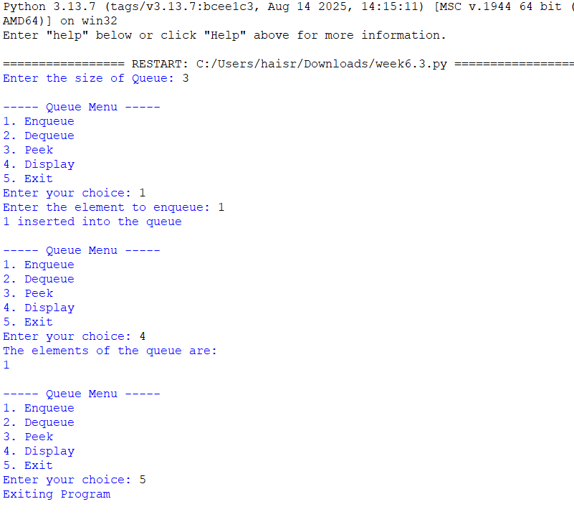

EXPLANATION:
1. Node Linking
· self.next = None : Initializes the node link as empty.
· new_node = Node(x) : Creates a new node with the given data.
· new_node.next = new_node : Makes the first node point to itself, forming a circular link.
2. Circular Connection During Enqueue
· new_node.next = self.front : Connects the new node to the first node.
· self.rear.next = new_node : Connects the current last node to the new node.
· self.rear = new_node : Updates the last node to the newly inserted node.
3. Circular Connection During Dequeue
· self.front = self.front.next : Moves front to the next node.
· self.rear.next = self.front : Reconnects the last node to the new front node.
· if self.front == self.rear: : Checks whether only one node exists.
· self.front = None : Removes the only node by clearing the front reference.
· self.rear = None : Clears the rear reference.
4. Circular Traversal
· temp = self.front : Starts traversal from the first node.
· temp = temp.next : Moves to the next linked node.
· if temp == self.front: : Detects that traversal has returned to the first node.
· break : Stops traversal after one complete circular cycle.
5. Node Data Access
· self.front.data : Accesses the data stored in the front node.
· temp.data : Accesses the data of the current node during traversal.
ERROR TABLE:
S.NO Error Obtained Rectification
1.
new_node.next is not connected to front, breaking the circular link.
Set new_node.next = self.front.
2.
self.rear.next is not updated after insertion or deletion.
Update self.rear.next = new_node during enqueue and self.rear.next = self.front during.

